**Re-Certification Folder Process**

**HCB Blue folders**

* **Section 1:** Keep all certification forms in the file. Any old correspondence and checklists get pulled out.
* **Section 2:** Pull all information out for off-storage. Exception: Keep the CIR training certificate in the file if it was not re-submitted.
* **Section 3:** Pull all information out for off-storage. Keep tabs for re-use.
* **Section 4:** Only remove the Program Administrator information if there has been a change to this information. If it is the same PA keep the information in the file.
* **Section 5:** Only remove the policies that have been updated and replace with current policies. Otherwise, keep this information in the file.
* **Section 6:** This is permanent information so do not remove. Please note that is Section 6.2 there may be information/policies that were submitted during a compliance review that needs to be incorporated into the file.

SST folders and updates site based Residential Habilitation providers. Please put each home’s license in the order it is listed on the site form and place in section 3-5.

**Care Coordination Folders**

The materials in these folder is not moved around except in the rare case that the folder is too full then it is processed for offsite storage. Otherwise do the following:

* **Left side:** Current materials on top Certification form, check list, application, and BCU form
* **Right side:** Training, education and resume
* Materials should be oldest on bottom to newest on top
* If the label for the file has a CM number or CMX replace the label with the correct format

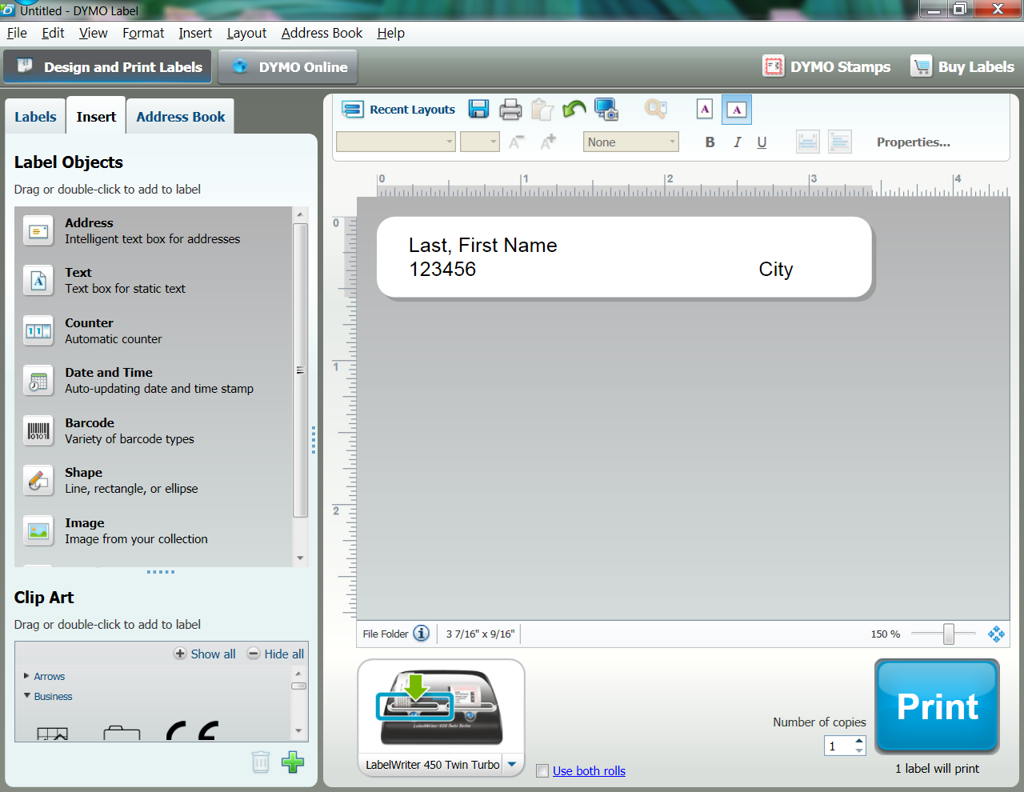

**PCA Folders**

PCA Folders are similar to HCB Folders in setup and archive materials as follows:

* **Section 1:** Keep all certification forms, old correspondence and checklists move to offsite
* **Section 2:** remove old application form, only keep CIR Certificate if new one has not been submitted
* **Section 3:** remove everything as new materials should have been submitted during recertification. Keep tabs for re-use
* **Section 4:** only remove policies that have been updated
* **Section 5:** only remove information that has been updated
* **Section 6:** never remove

The materials pulled out of the folder should be placed in a manila folder and labeled as follows to show the Agency Name, Provider #, Physical City of Agency, and Current certification period you are archiving.

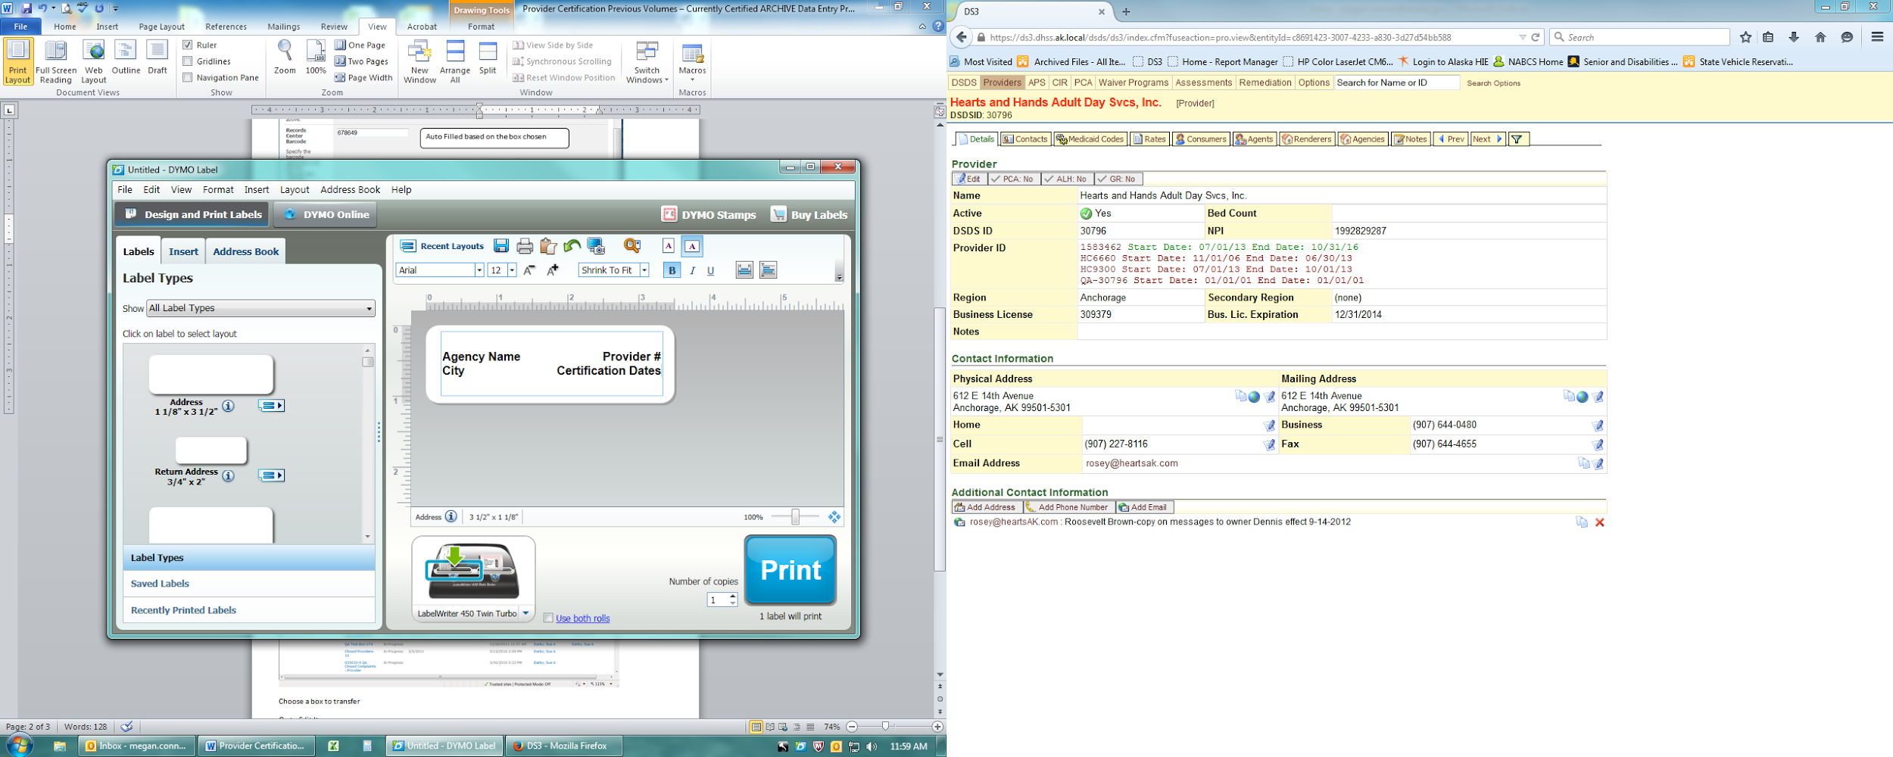or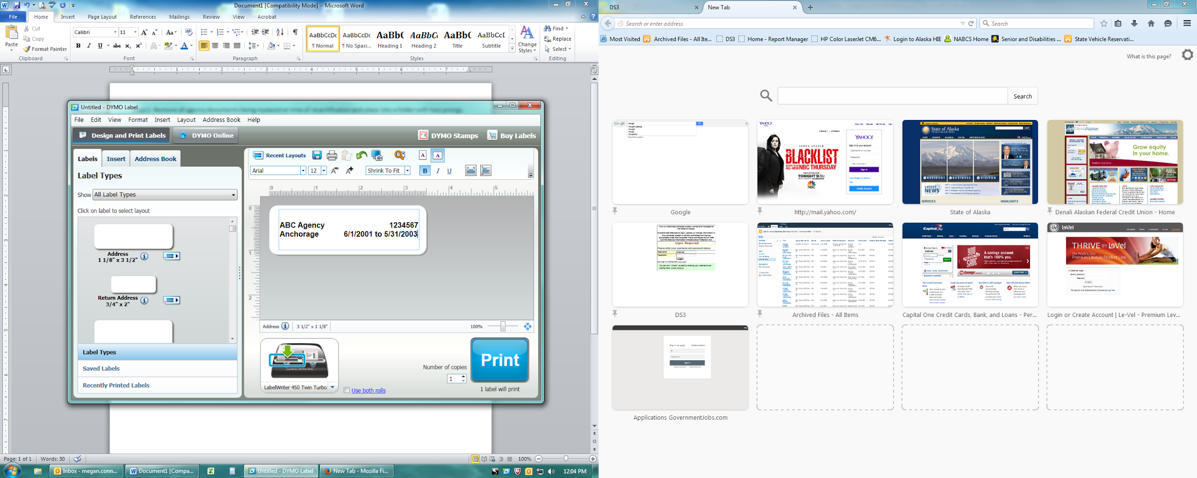

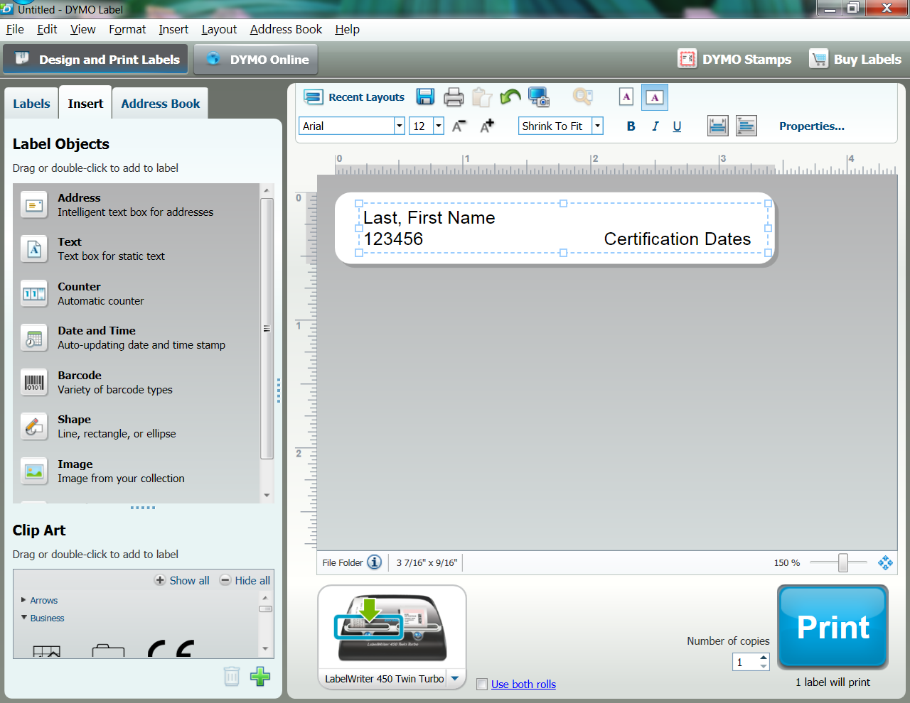 for Care Coordinators